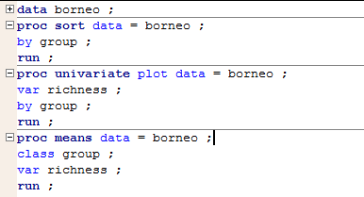Homework 11

Yubing Li

**(25.8)**

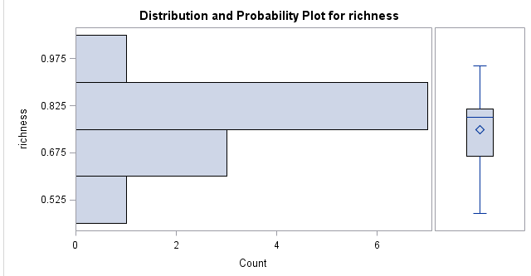Group 1

Not very symmetric

Approximately Normal

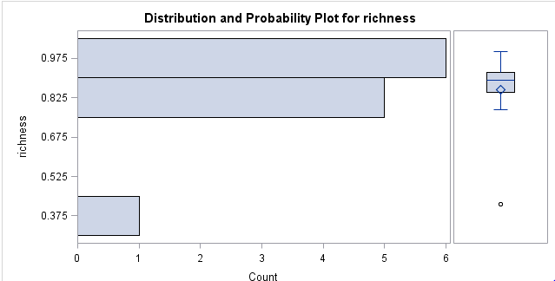Group 2

Symmetric

Not Normal distributed

Group 3

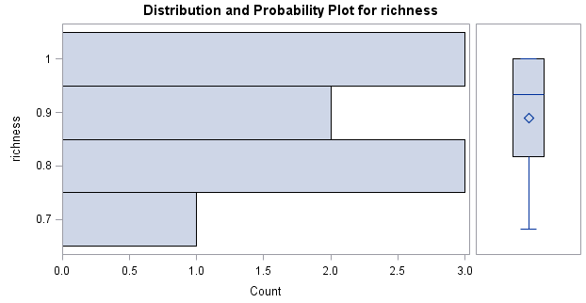

Not very symmetric

Not Normal distributed

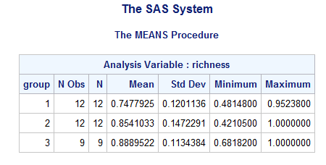

0.682 < 0.421 ∗ 2

Satisfied

In all, the data set does not satisfy the normal and symmetric assumption, it’s risky to use ANOVA.

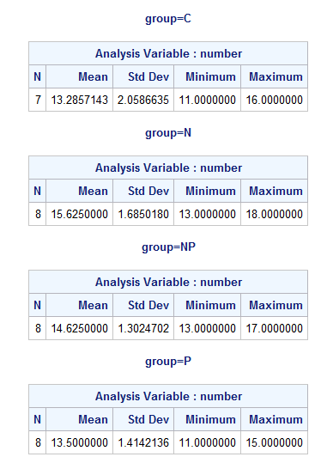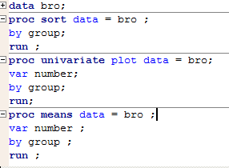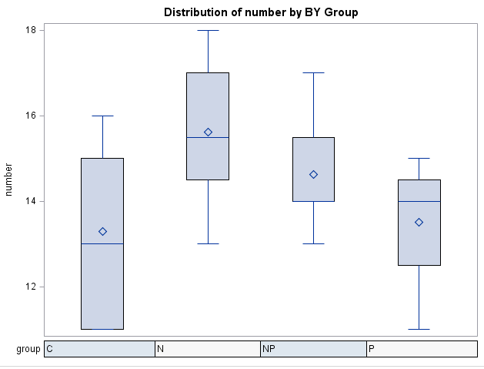**(25.9)**

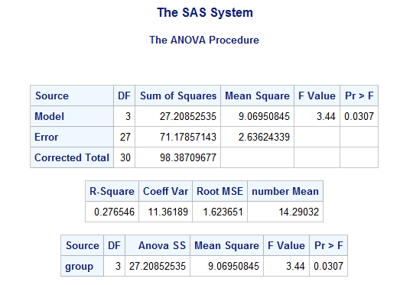

In all, the data set seems to satisfy Normal assumption and 2.0587 < 1.3025 * 2.

So it’s safe to use ANOVA.

The F Value = 3.44 and p-val = 0.0307 < α = 0.05.

We can say that the four groups are significantly different.

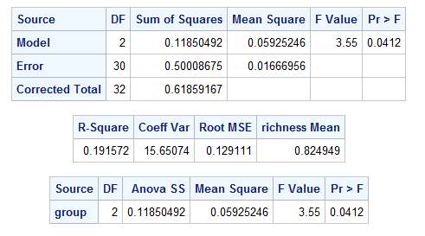**(25.10)**

**(a)**

I = 3

n1 = 12, n2 = 12, n3 = 9

N = 33

**(b)** For ANOVA F test, df in numerator = 2, df in denominator = 30

**(25.28)**

**(a)** 1.5 < 0.87 * 2 satisfy the criteria for ANOVA.

When seeing a model, males rate higher than females. When seeing a student, males rate lower than females. We might say that males are more influenced by the attractiveness.

**(b)** I = 5; N = 22+23+24+23+27 = 119

For f (4,114), the p-val < 0.01 < α = 0.05, therefore, we can say there’s sufficient evidence to say the five groups are not equal.